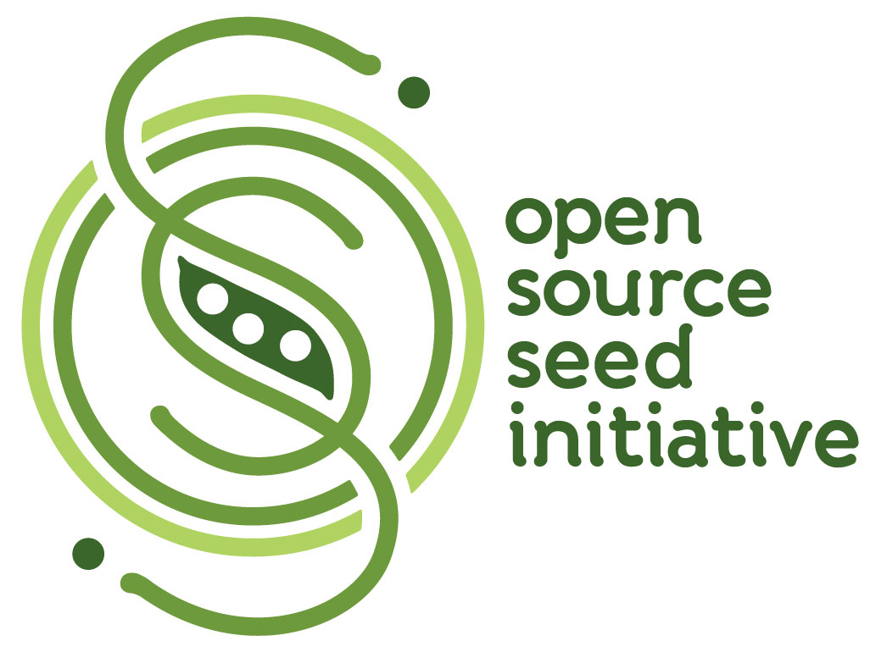 | The OSSI Pledge – You have the freedom to use these OSSI seeds in any way you choose. In return, you pledge not to restrict others' use of these seeds or their derivatives by patents or other means, and to include this pledge with any transfer of these seeds or their derivatives. |  | The OSSI Pledge – You have the freedom to use these OSSI seeds in any way you choose. In return, you pledge not to restrict others' use of these seeds or their derivatives by patents or other means, and to include this pledge with any transfer of these seeds or their derivatives.
 | The OSSI Pledge – You have the freedom to use these OSSI seeds in any way you choose. In return, you pledge not to restrict others' use of these seeds or their derivatives by patents or other means, and to include this pledge with any transfer of these seeds or their derivatives. |  | The OSSI Pledge – You have the freedom to use these OSSI seeds in any way you choose. In return, you pledge not to restrict others' use of these seeds or their derivatives by patents or other means, and to include this pledge with any transfer of these seeds or their derivatives.
 | The OSSI Pledge – You have the freedom to use these OSSI seeds in any way you choose. In return, you pledge not to restrict others' use of these seeds or their derivatives by patents or other means, and to include this pledge with any transfer of these seeds or their derivatives. |  | The OSSI Pledge – You have the freedom to use these OSSI seeds in any way you choose. In return, you pledge not to restrict others' use of these seeds or their derivatives by patents or other means, and to include this pledge with any transfer of these seeds or their derivatives.
 | The OSSI Pledge – You have the freedom to use these OSSI seeds in any way you choose. In return, you pledge not to restrict others' use of these seeds or their derivatives by patents or other means, and to include this pledge with any transfer of these seeds or their derivatives. |  | The OSSI Pledge – You have the freedom to use these OSSI seeds in any way you choose. In return, you pledge not to restrict others' use of these seeds or their derivatives by patents or other means, and to include this pledge with any transfer of these seeds or their derivatives.
 | The OSSI Pledge – You have the freedom to use these OSSI seeds in any way you choose. In return, you pledge not to restrict others' use of these seeds or their derivatives by patents or other means, and to include this pledge with any transfer of these seeds or their derivatives. |  | The OSSI Pledge – You have the freedom to use these OSSI seeds in any way you choose. In return, you pledge not to restrict others' use of these seeds or their derivatives by patents or other means, and to include this pledge with any transfer of these seeds or their derivatives.
 | The OSSI Pledge – You have the freedom to use these OSSI seeds in any way you choose. In return, you pledge not to restrict others' use of these seeds or their derivatives by patents or other means, and to include this pledge with any transfer of these seeds or their derivatives. |  | The OSSI Pledge – You have the freedom to use these OSSI seeds in any way you choose. In return, you pledge not to restrict others' use of these seeds or their derivatives by patents or other means, and to include this pledge with any transfer of these seeds or their derivatives.
 | The OSSI Pledge – You have the freedom to use these OSSI seeds in any way you choose. In return, you pledge not to restrict others' use of these seeds or their derivatives by patents or other means, and to include this pledge with any transfer of these seeds or their derivatives. |  | The OSSI Pledge – You have the freedom to use these OSSI seeds in any way you choose. In return, you pledge not to restrict others' use of these seeds or their derivatives by patents or other means, and to include this pledge with any transfer of these seeds or their derivatives.
 | The OSSI Pledge – You have the freedom to use these OSSI seeds in any way you choose. In return, you pledge not to restrict others' use of these seeds or their derivatives by patents or other means, and to include this pledge with any transfer of these seeds or their derivatives. |  | The OSSI Pledge – You have the freedom to use these OSSI seeds in any way you choose. In return, you pledge not to restrict others' use of these seeds or their derivatives by patents or other means, and to include this pledge with any transfer of these seeds or their derivatives.

